1. Implementing singleton pattern example

Program

public class Logger {

private static Logger singleInstance;

private Logger() {

System.out.println("Logger instance created");

}

public static Logger getInstance() {

if (singleInstance == null) {

singleInstance = new Logger();

}

return singleInstance;

}

public void log(String message) {

System.out.println("Log message: " + message);

}

}

public class TestLogger {

public static void main(String[] args) {

Logger logger1 = Logger.getInstance();

logger1.log("this is the First log message");

Logger logger2 = Logger.getInstance();

logger2.log("this is the Second log message");

if (logger1 == logger2) {

System.out.println("Only one instance of Logger exists.");

} else {

System.out.println("Different instances exist. Singleton failed.");

}

}

}

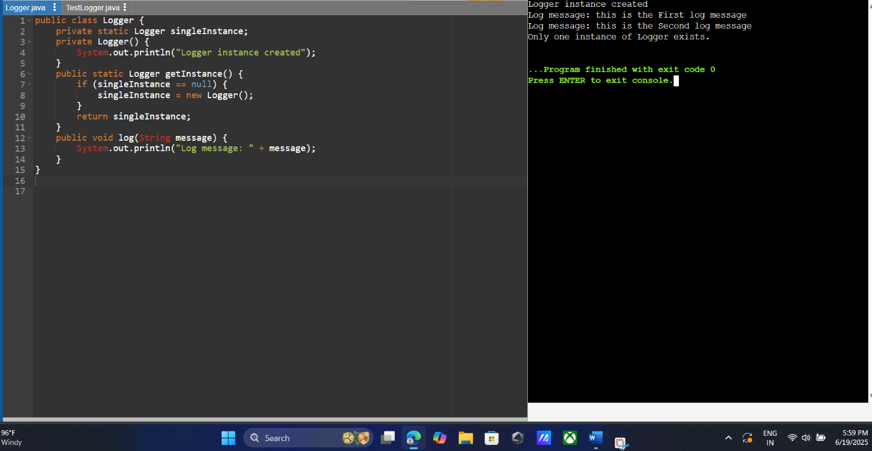

1. Implementing the factory method pattern

Program

interface Document {

void open();

}

class WordDocument implements Document {

public void open() {

System.out.println("Opening a Word document.");

}

}

class PdfDocument implements Document {

public void open() {

System.out.println("Opening a PDF document.");

}

}

class ExcelDocument implements Document {

public void open() {

System.out.println("Opening an Excel document.");

}

}

abstract class DocumentFactory {

public abstract Document createDocument();

}

class WordDocumentFactory extends DocumentFactory {

public Document createDocument() {

return new WordDocument();

}

}

class PdfDocumentFactory extends DocumentFactory {

public Document createDocument() {

return new PdfDocument();

}

}

class ExcelDocumentFactory extends DocumentFactory {

public Document createDocument() {

return new ExcelDocument();

}

}

public class FactoryMethodPatternExample {

public static void main(String[] args) {

DocumentFactory wordFactory = new WordDocumentFactory();

Document wordDoc = wordFactory.createDocument();

wordDoc.open();

DocumentFactory pdfFactory = new PdfDocumentFactory();

Document pdfDoc = pdfFactory.createDocument();

pdfDoc.open();

DocumentFactory excelFactory = new ExcelDocumentFactory();

Document excelDoc = excelFactory.createDocument();

excelDoc.open();

}} 